

AWS First Cloud AI Journey – Project Plan

T1VN – FPT University – Jewelry Web Store

03/12/2025

Table of Contents
1 BACKGROUND AND MOTIVATION 3
1.1 EXECUTIVE SUMMARY 3
1.2 PROJECT SUCCESS CRITERIA 3
1.3 ASSUMPTIONS 3
2 SOLUTION ARCHITECTURE / ARCHITECTURAL DIAGRAM 4
2.1 TECHNICAL ARCHITECTURE DIAGRAM 4
2.2 TECHNICAL PLAN 4
2.3 PROJECT PLAN 5
2.4 SECURITY CONSIDERATIONS 5
3 ACTIVITIES AND DELIVERABLES 6
3.1 ACTIVITIES AND DELIVERABLES 6
3.2 OUT OF SCOPE 8
3.3 PATH TO PRODUCTION 8
4 EXPECTED AWS COST BREAKDOWN BY SERVICES 9
5 TEAM 10
6 RESOURCES & COST ESTIMATES 10
7 ACCEPTANCE 11

BACKGROUND AND MOTIVATION

EXECUTIVE SUMMARY
The AWS Jewelry Web project entails the development of a comprehensive Jewelry E-commerce Platform. The system architecture comprises a backend and database infrastructure hosted on AWS Lightsail, coupled with a React-based frontend deployed via Amazon S3 and CloudFront. This architecture is designed to ensure scalability, high security, and operational cost optimization by leveraging essential yet highly effective Cloud services.

The system provides the following key features:
- Jewelry product management.
- Product image uploading capabilities.
- Shopping cart functionality.
- User registration and authentication via AWS Cognito.
- Backend API operations on Lightsail with MySQL/Postgres data storage.
- Content delivery acceleration and international standard SSL processing via CDN.

PROJECT SUCCESS CRITERIA
- Performance: Website load time under 2 seconds for international access, facilitated by CloudFront CDN.
- Stability: Backend operates stably on Lightsail under actual traffic conditions.
- Data Integrity: Secure database operations with rapid retrieval speeds.
- User Management: Stable and secure user management via Amazon Cognito.
- Security: Secure image uploading processes via Amazon S3.
- Monitoring: Comprehensive API logging through Amazon CloudWatch.

ASSUMPTIONS
- Traffic Volume: Moderate traffic levels (less than 100,000 requests/month).
- Scaling: No requirement for advanced autoscaling configurations.
- Domain: Domain name is pre-acquired or will be purchased via Amazon Route 53.
- Competency: The development team possesses proficiency in Node.js and React.

SOLUTION ARCHITECTURE / ARCHITECTURAL DIAGRAM

TECHNICAL ARCHITECTURE DIAGRAM
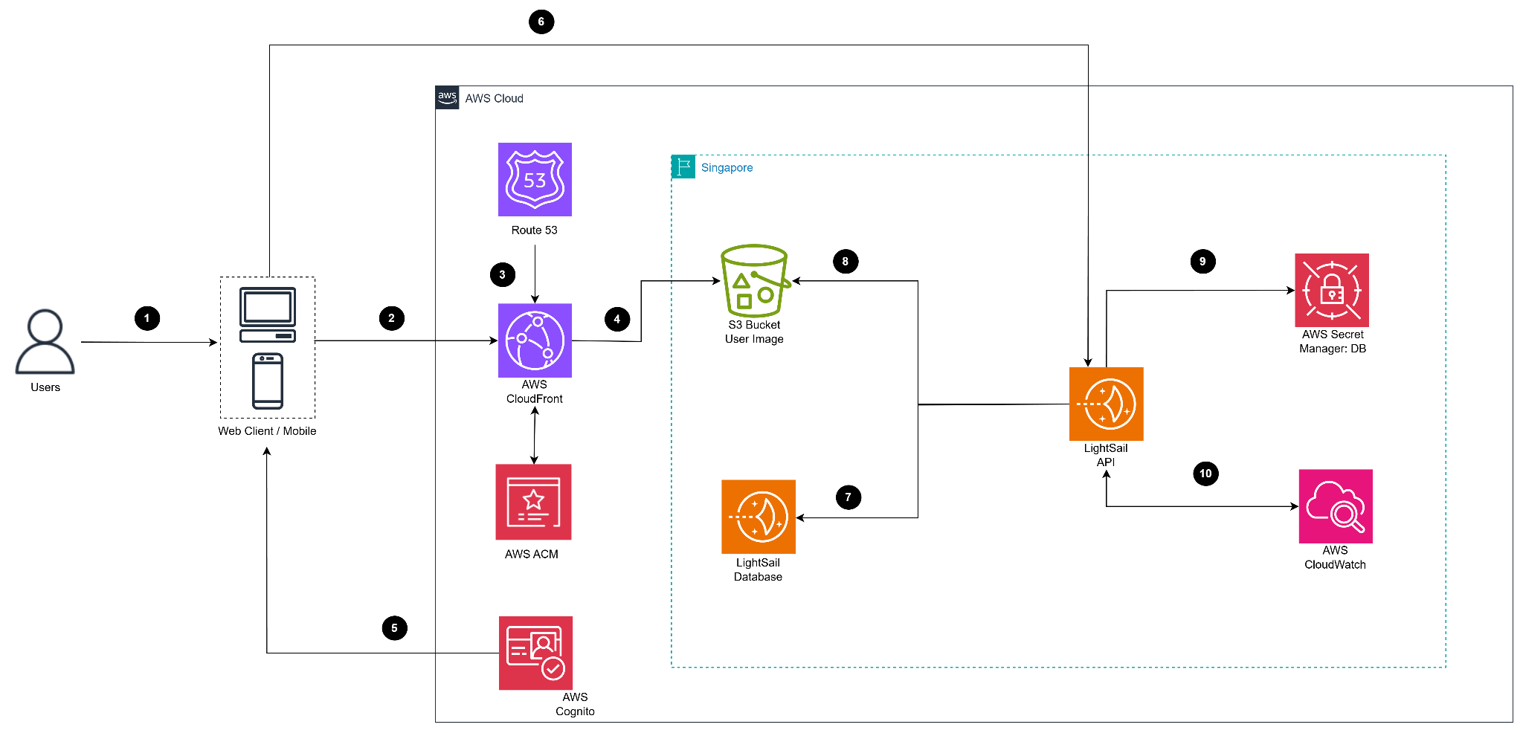

TECHNICAL PLAN
- Frontend: Hosted on Amazon S3 with Amazon CloudFront CDN and HTTPS enabled via AWS Certificate Manager (ACM).
- Backend API: .NET runtime environment on AWS Lightsail.
- Database: MySQL/PostgreSQL hosted on AWS Lightsail.
- Authentication: Amazon Cognito User Pool.
- Image Storage: Amazon S3.
- Logging: Amazon CloudWatch.
- Secrets Management: AWS Secrets Manager.

PROJECT PLAN
The implementation timeline is estimated to range from 6 to 12 weeks, contingent upon the final project scope.

SECURITY CONSIDERATIONS
- Access Control: S3 private access configured, granting read permissions exclusively to CloudFront.
- Credential Management: API utilizes private keys stored securely in AWS Secrets Manager.
- Encryption: Full system-wide HTTPS implementation.
- Authentication Security: User login protected by Amazon Cognito.

ACTIVITIES AND DELIVERABLES

ACTIVITIES AND DELIVERABLES

Project Phase | Timeline | Activities | Deliverables / Milestones | MD
Assessment | Week 1 | - Analyze the Jewelry Web system requirements.  - Draft the Architecture Diagram.  - Design the Database Schema (Lightsail MySQL/Postgres).  - Identify necessary secrets (DB password, bucket name). | - Architecture Diagram  - DB Schema  - List of Secrets | 5
Setup Base Infrastructure | Week 2 | - Configure S3 hosting and React build.  - Configure CloudFront CDN and ACM SSL.  - Map domain via Route 53.  - Provision Lightsail API instance.  - Provision Lightsail Database.  - Configure Cognito Login.  - Create Secrets Manager entries:  + Secret 1: DB_PASSWORD  + Secret 2: APP_CONFIG (bucket-name)  - Assign IAM roles to API instances for secret retrieval permissions.  - Enable CloudWatch logs. | - Functional Frontend CDN  - Operational Backend API  - Database connectivity established  - Functional Cognito login  - Secrets Manager populated with DB password & bucket name | 7

Setup Component 1 – Backend API | Week 3 | - Implement API logic to retrieve DB password from Secrets Manager.  - Implement API logic to retrieve bucket names from Secrets Manager.  - Implement image upload to S3 (via presigned URL).  - Develop CRUD operations for jewelry products.  - Integrate Cognito authentication.  - Implement log transmission to CloudWatch. | - Stable API operations  - Successful image upload functionality  - Successful Login functionality  - Hardcoded configurations fully replaced by Secrets Manager | 7
Setup Component 2 – Frontend React | Week 4 | - Develop Jewelry Shop UI.  - Implement Cognito Login interface.  - Implement jewelry image upload interface.  - Fetch data from API.  - Build and deploy to S3 + CloudFront. | - Complete User Interface (UI)  - API Integration established | 7
Testing &  Go-live | Week 5 | - Integration testing (FE ↔ BE ↔ S3 ↔ DB).  - Security testing (IAM + Secrets Manager).  - End-to-end testing. | - Test Report  - Security checklist | 5
Handover | Week 6 | - Provide instruction on using Secrets Manager for updating bucket names/DB passwords.  - Transfer AWS account ownership.  - Provide Runbook Documentation. | - Comprehensive Runbook  - Project Closure | 5

OUT OF SCOPE
- AI/Machine Learning features.
- Complex E-commerce functionalities.
- Advanced image processing capabilities.
- Multi-region deployment or Disaster Recovery (DR) sites.
- Complex administrative systems.
- Integration with third-party systems.

PATH TO PRODUCTION
- Operational Excellence Optimization.
- Secrets Management – Production Hardening.
- Extended Error Handling.
- Deployment & Production Verification.
- Disaster Recovery Plan.
- Production Handover.

EXPECTED AWS COST BREAKDOWN BY SERVICES
Service Name | Upfront cost | Monthly cost | Region
Amazon S3 | 0.00 USD | 0.26 USD | Asia Pacific (Singapore)
Amazon CloudFront (CDN cho FE) | 0.00 USD | 0.17 USD | Asia Pacific (Singapore)
AWS ACM | 0.00 USD | 0 USD | Asia Pacific (Singapore)
Amazon Route 53 | 0.00 USD | 0.50–1.00 USD | Asia Pacific (Singapore)
AWS Lightsail – Database | 0.00 USD | 10–15 USD | Asia Pacific (Singapore)
Amazon Cognito | 0.00 USD | 2.00 USD | Asia Pacific (Singapore)
AWS Secrets Manager | 0.00 USD | 0.40 USD | Asia Pacific (Singapore)
Amazon CloudWatch | 0.00 USD | 0.30 USD | Asia Pacific (Singapore)
AWS Lightsail – API Server | 0.00 USD | 5 - 10 USD | Asia Pacific (Singapore)

TEAM
Partner Executive Sponsor
Name | Title | Description | Email / Contact Info
Project Stakeholders
Name | Title | Stakeholder for | Email / Contact Info
Partner Project Team
Name | Title | Role | Email / Contact Info
Nguyễn Duy Hiếu | Product Owner | Project Manager (BE) | Hieundse185047@fpt.edu.vn
Lưu Ngọc Ngân Giang | Software Developer | Developer (BE) | luungocngangiang25@gmail.com
Nguyễn Huy Hoàng | Software Developer | Developer (FE) | Hoangnhse185092@fpt.edu.vn
Trần Hồ Phương Khanh | Software Developer | Developer (FE) | khanhthpse185070@fpt.edu.vn
Tăng Khanh Nhi | Software Developer | Developer (FE) | tangkhanhnhi111@gmail.com
Project Escalation Contacts
Name | Title | Role | Email / Contact Info

RESOURCES & COST ESTIMATES

Resource | Responsibility | Rate (USD) / Hour
Solution Architects [number of assigned headcount] | - Design and architect the AWS infrastructure ecosystem, incorporating services such as S3, CloudFront, Lightsail, ACM, Route 53, and Secrets Manager.  - Provide strategic consultancy regarding security protocols and operational cost optimization.  - Conduct comprehensive reviews of deployment procedures to ensure adherence to industry best practices. | 12
Engineers [number of assigned headcount] | - Execute the provisioning and deployment of core infrastructure components, including S3, CloudFront, Route 53, ACM, and Lightsail.  - Establish Continuous Integration/Continuous Deployment (CI/CD) pipelines and facilitate the deployment of frontend assets to Amazon S3.  - Deploy and configure the Node.js API runtime environment within the AWS Lightsail infrastructure.  - Configure secure credential management via AWS Secrets Manager and establish logging mechanisms using Amazon CloudWatch. | 6
Other (Please specify) | - Perform rigorous post-deployment system verification and integration testing.  - Deliver ongoing technical consultation and dedicated client support services. | 0

* Note: Refer to section “activities & deliverables” for the list of project phases
Project Phase | Solution Architects | Engineers | Other  (Please specify) | Total Hours
S3 + CloudFront | 1 | 2 |  | 3
Lightsail API + DB | 1 | 4 |  | 4
Cognito | 1 | 2 |  | 5
Logging & Monitoring | 1 | 1 |  | 3
Total Hours | 4 | 12 |  | 15
Total Cost

AWS Calculate: https://calculator.aws/#/estimate?id=621f38b12a1ef026842ba2ddfe46ff936ed4ab01
Service Name | Upfront Cost | Monthly Cost | Description | Region | Config Summary
AWS Secrets Manager | 0.00 USD | 0.13 USD | DB Password Management | Asia Pacific (Singapore) | Number of secrets (1), Average duration of each secret (10 days), Number of API calls (1 per month)
AWS Certificate Manager | 15.00 USD | 0.00 USD | SSL Certificate | Asia Pacific (Singapore) | Number of fully qualified domain names (FQDNs) (1)
Amazon S3 | 0.00 USD | 0.03 USD | Host React + Image Storage | Asia Pacific (Singapore) | S3 Standard storage (1 GB/mo), Data Transfer In/Out (0 TB/mo)
Amazon Route 53 | 0.00 USD | 3.50 USD | Domain Management | Asia Pacific (Singapore) | Hosted Zones (1)
Amazon Lightsail | 0.00 USD | 3.20 USD | API + Database Server | Asia Pacific (Singapore) | 1 Bundle, Storage (100GB), Data Transfer (250GB), Additional storage (8 GB)
Amazon Cognito | 0.00 USD | 0.05 USD | User Login/Auth | Asia Pacific (Singapore) | MAU (1), Advanced security features (Enabled)
Amazon CloudWatch | 0.00 USD | 0.30 USD | API Logging | Asia Pacific (Singapore) | Metrics requested (1), Widget Image (1), Other API requests (1), Custom Metrics (1)
Amazon CloudFront | 0.00 USD | 0.00 USD | Frontend CDN | Asia Pacific (Singapore) | Free Plan (1)
TOTAL | 15.00 USD | ~7.21 USD

Cost Contribution distribution between Partner, Customer, AWS:
Party | Contribution (USD) | % Contribution of Total
Customer
Partner
AWS

ACCEPTANCE
Project is complete when: 09/12/2025
Website runs stably on real domain.
API fully connects to DB.
Upload product images works.
CloudWatch log & Cognito login works.
Accepted by customer/stakeholder.

